Windows commands

Ipconfig
Syntax: ipconfig
Function: cmd to show the NIC ip config and basic details.
More details: Refer Microsoft Learn
Example: 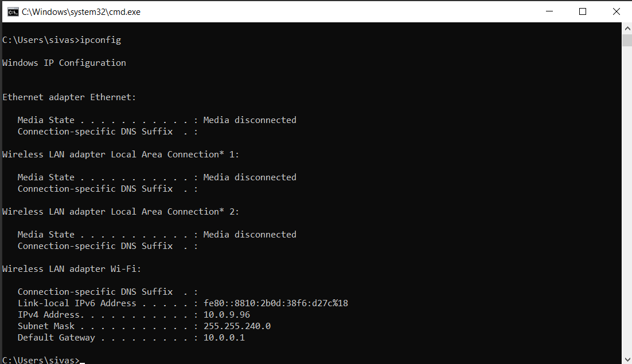

ipconfig /all
Syntax: ipconfig /all
Function: cmd to show the all NIC details.

ipconfig /flushdns
Syntax: ipconfig /flushdns
Function: cmd to clear the DNS cache.

Ping

2.1 Ping:
Syntax: ping <ip address>
Function: cmd to check weather the destination computer is reachable or not.
More details: Refer Microsoft Learn
Example:
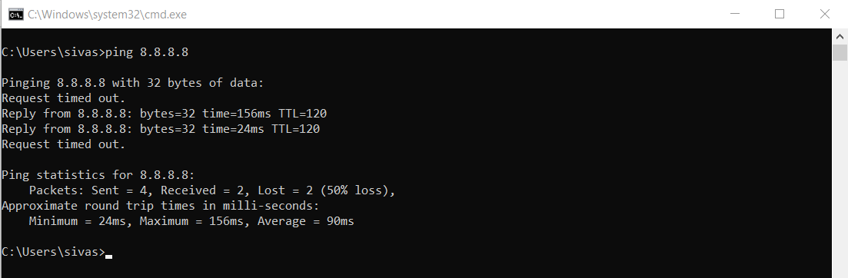

2.2 Ping with timestamp:
Syntax: ping -t <ip address> |Foreach{"{0} - {1}" -f (Get-Date),$_}
Function: it will work in PowerShell. Normal ping cmd show the reply details of the destination computer but cmd will show the replay with timestamp.
More details: Refer Spiceworks
Example:
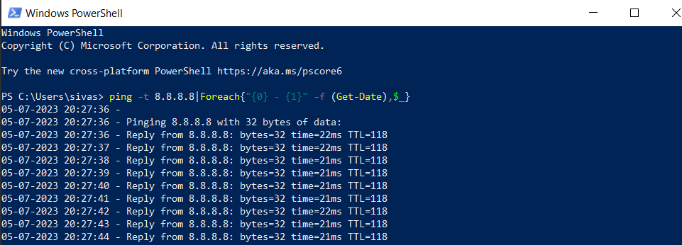

Path ping
Syntax: pathping <ip address>
Function: cmd to check the packet loss and no of hops between source and destination.
More details: Refer Microsoft Learn
Example: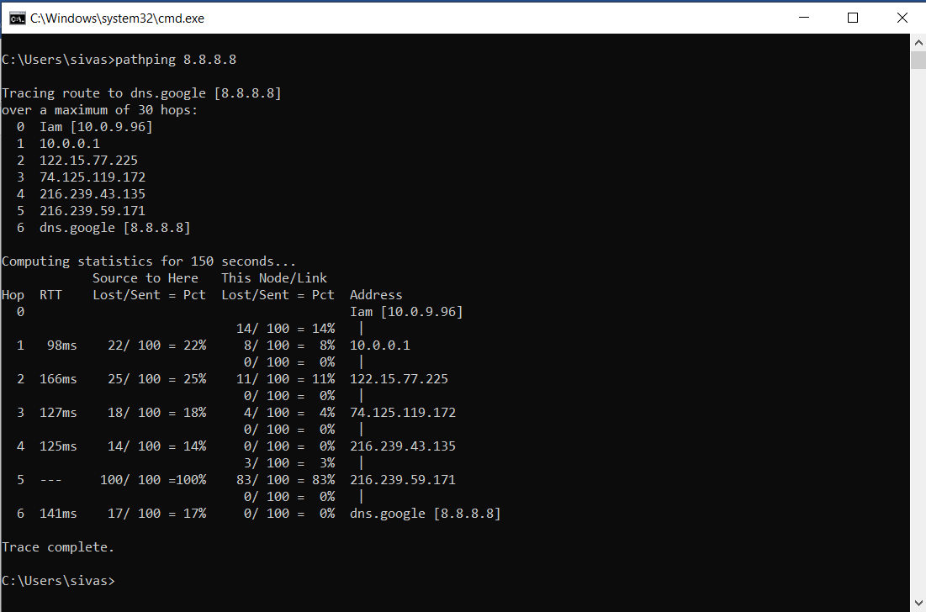

Tracert
Syntax: tracert <ip address>
Function: cmd to check the hops and no of router between source and destination.
More details: Refer Microsoft Learn
Example:
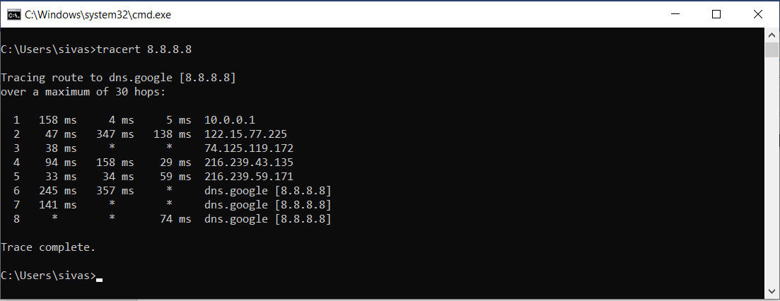

Nslookup
Syntax: nslookup <domain name>
Function: cmd to resolve the dns name to ip.
More details: Refer Microsoft Learn
Example:
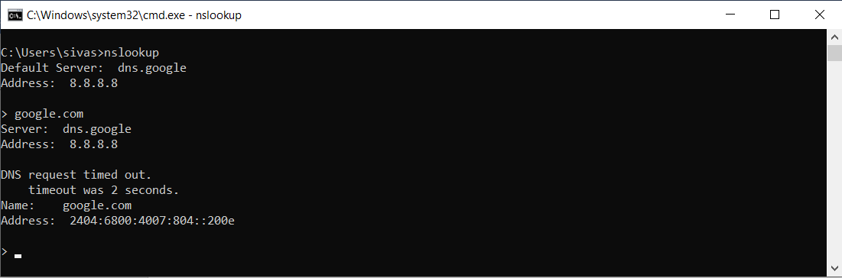

Wifi Qrcode generator
Syntax: new-qrcodewifiaccess -SSID "<wifi name>" -Password "<wifi password>" -outpath "<file path location to save file>"
Function: cmd to genetrate wifi qrcode in powershell
Installation cmds: Install-Module -Name QRCodeGenerator
Import-Module QRCodeGenerator
More details: Refer Generate QR Code with PowerShell in Windows 10
Example: 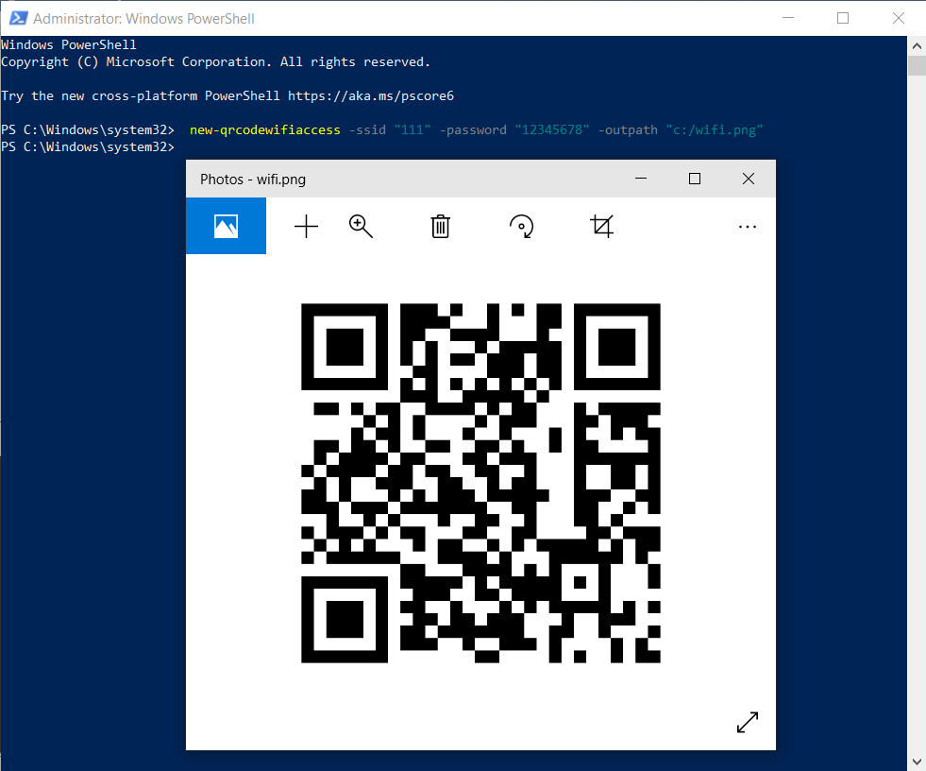

Attrib Command
Syntax: attrib “<folder name>” +s +h +r
Function: folder is hidden and isn't visible when we select to show all files and folders.
s System
h Hidden
r Read-only
Syntax: attrib “<folder name>” -s -h -r
Function: folder is visible when we select to show all files and folders.
More details: Refer www.c-sharpcorner.com
Example: 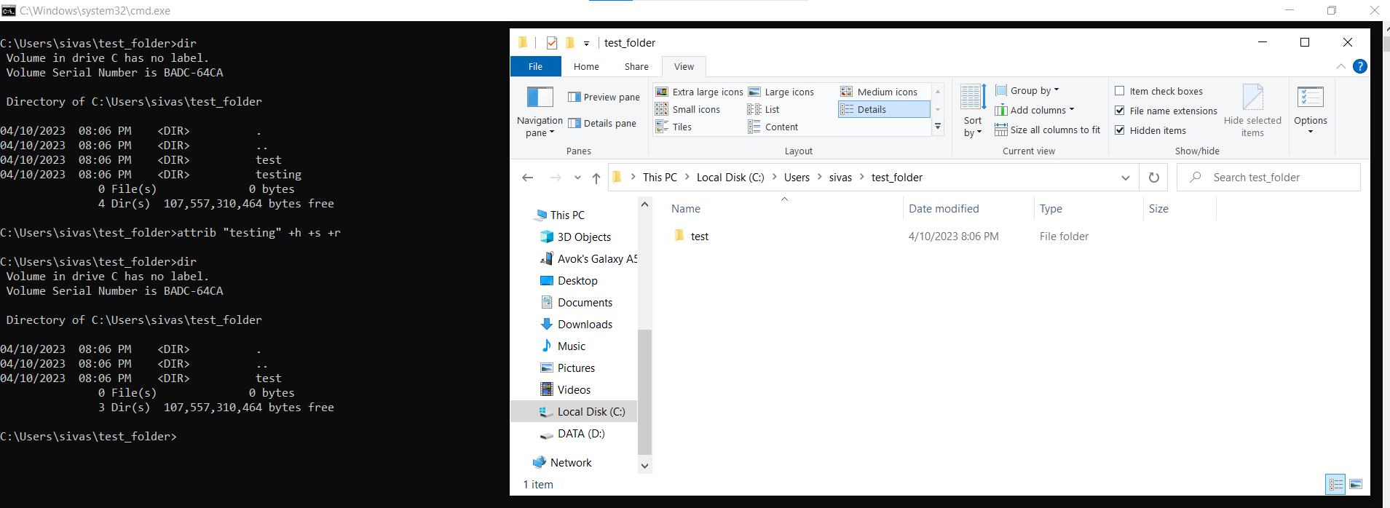

Title
Syntax: title <string>
Function: To change the Command Prompt title.
More details: Refer Microsoft Learn
Example:
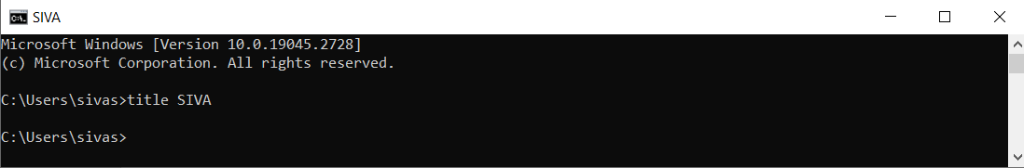

Prompt
Syntax: prompt <text>
Function: To change executing path name in command prompt.
More details: Refer Microsoft Learn
Example: 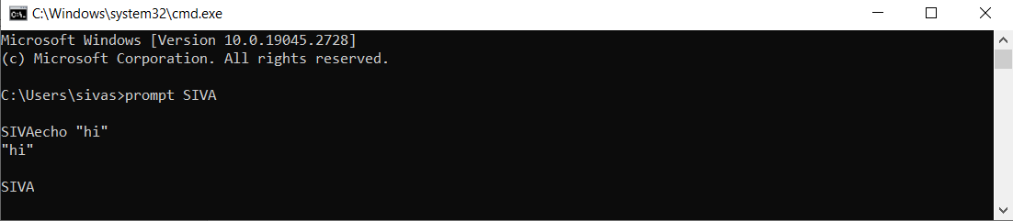

Netsh #wifi password
Syntax: netsh wlan show profile
Function: To show a list of network names that we already connect to.
Syntax: netsh wlan show profile name= “<Wi-Fi name>” key=clear
Function: To show the password of the given wi-fi name
More details: Refer Microsoft Learn
Example: 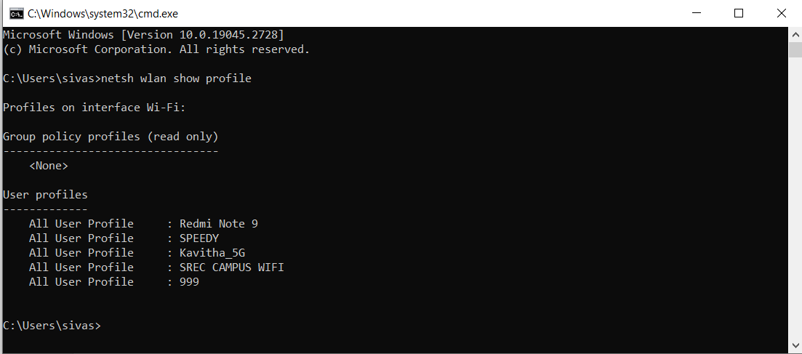

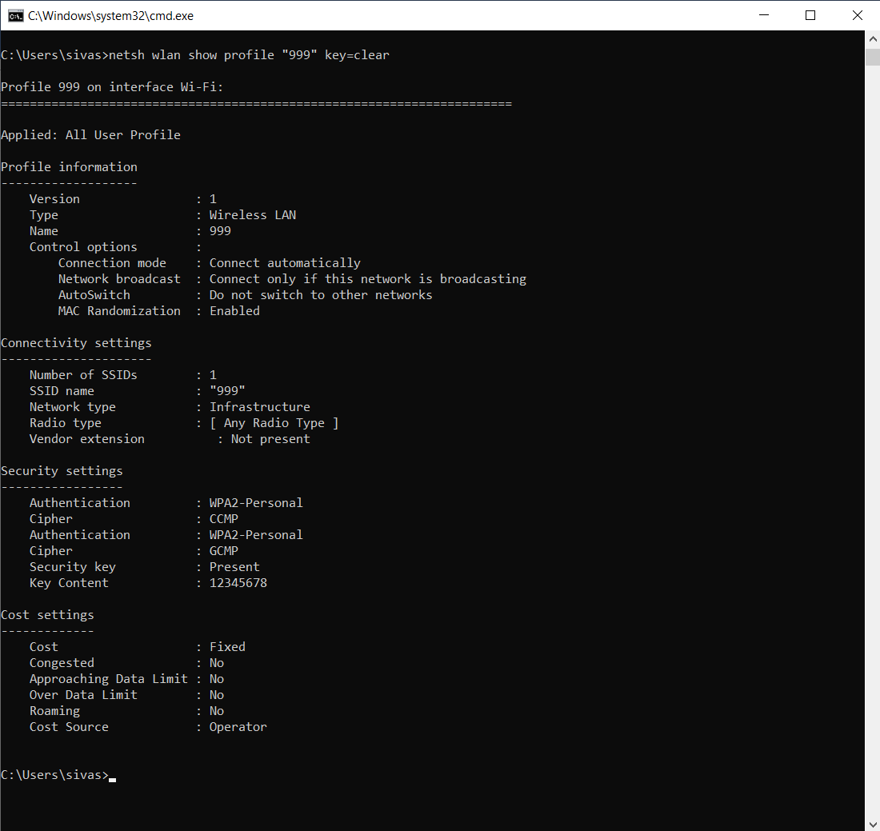
Syntax: netsh wlan show interface
Function: To show wifi interface details.
More details: Refer Udemy video
Example:
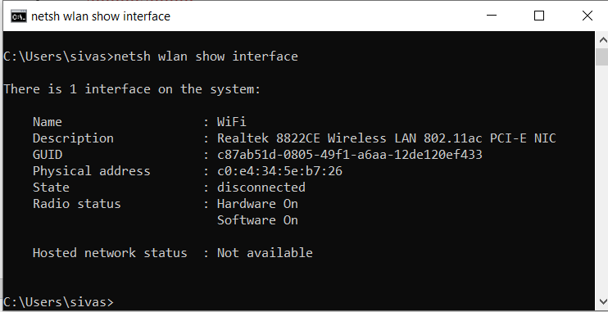
Syntax: netsh wlan show wlanreport
Function: To create the wireless network report. For execute this cmd run the command prompt as administrator mode.
More details: Refer Microsoft support
Example:
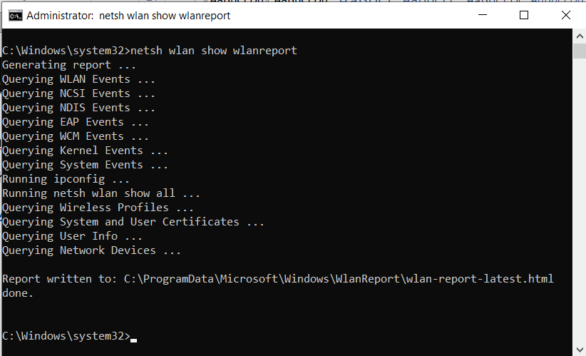

Manage-bde Bitlocker

Unlock:
Syntax: Manage-bde -unlock <drive letter>: -password
Function: run command prompt in Admin mode to unlock the bitlocker drive.
More details: Refer Microsoft Learn
Example:
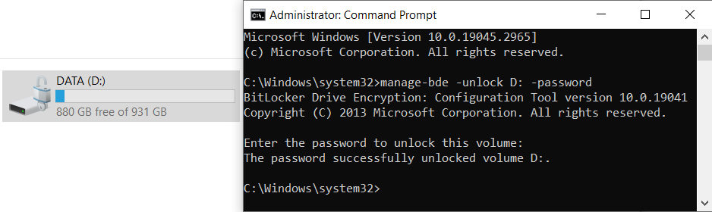

Here enter the password of Bitlocker dirve.

Lock:
Syntax: Manage-bde -lock <drive letter>:
Function: run command prompt in Admin mode to lock the bitlocker drive. If any application or file is opened in that drive location it will not lock.
More details: Refer Microsoft Learn
Example:
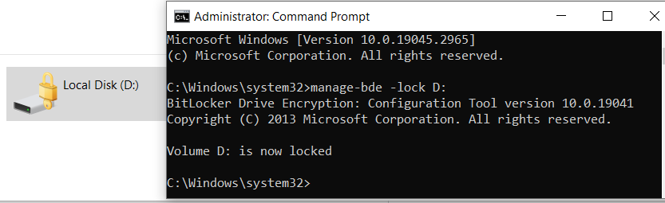

Force lock:
Syntax: Manage-bde -lock <drive letter>: -forcedismount
Function: run command prompt in Admin mode to lock the bitlocker drive. If any application or file is opened in that drive location then also it will lock the drive.
More details: Refer Microsoft Learn
Example:
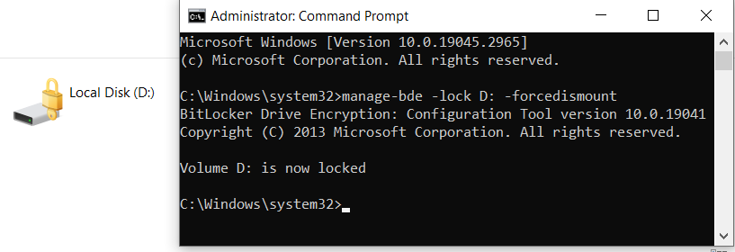

Activate Windows watermark temporary remove
Syntax: bcdedit -set TESTSIGNING OFF
Function: run command prompt in Admin mode, enter the command and reboot the computer. use this command to temporarily hide the Activate Windows watermark.
More details: I find in YT
Example:

Before
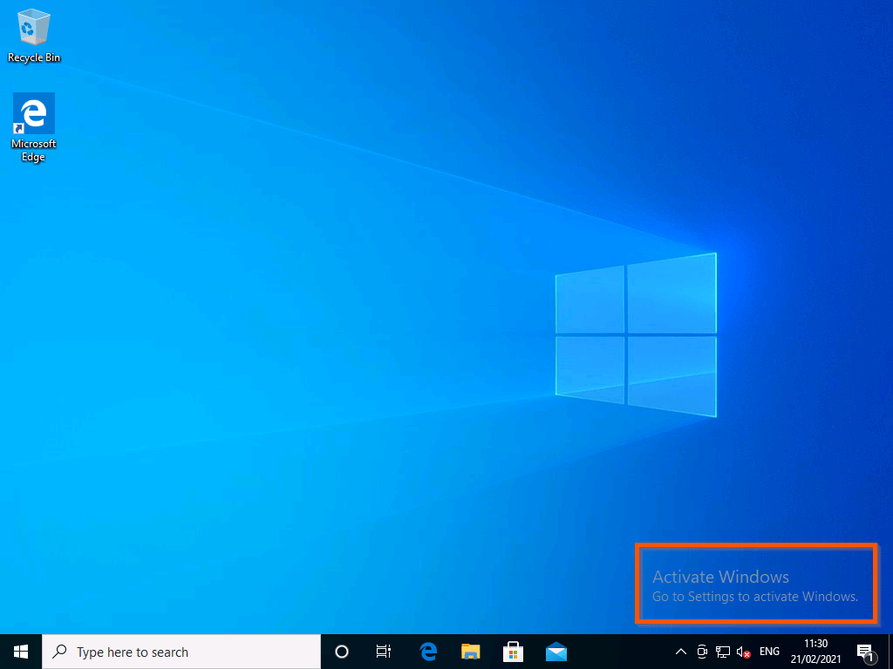
After
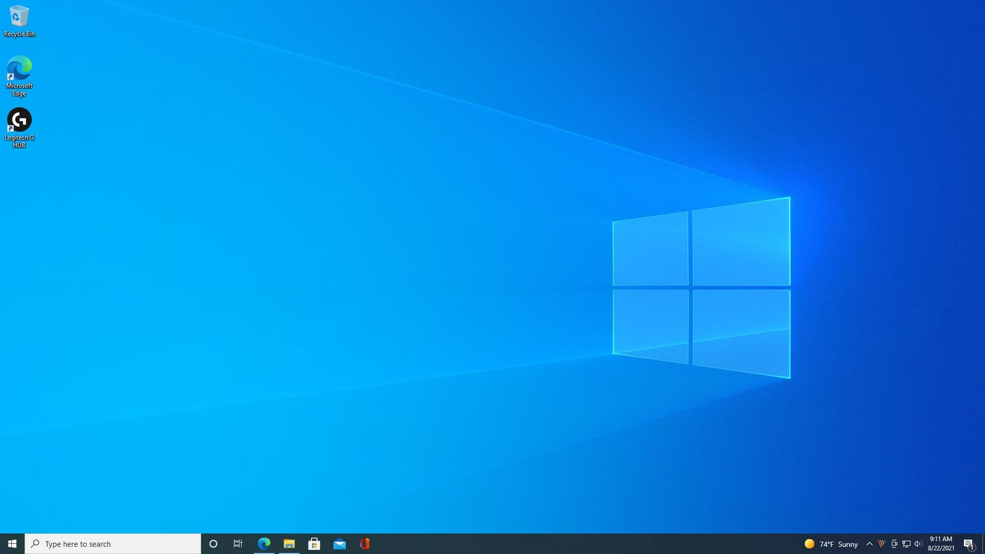

Display the content of a file in Command Prompt and PowerShell

Using Command Prompt:
Syntax: type “[<drive>:] [<path>] <file name.extension>”
Function: To view a text file without modifying it and show the file content in the CMD prompt. It limit the lines while display file content. Use MORE cmd with pipe symbol now now press spacebar to shows all the line in the large file.
More details: Refer Microsoft Learn
Example:
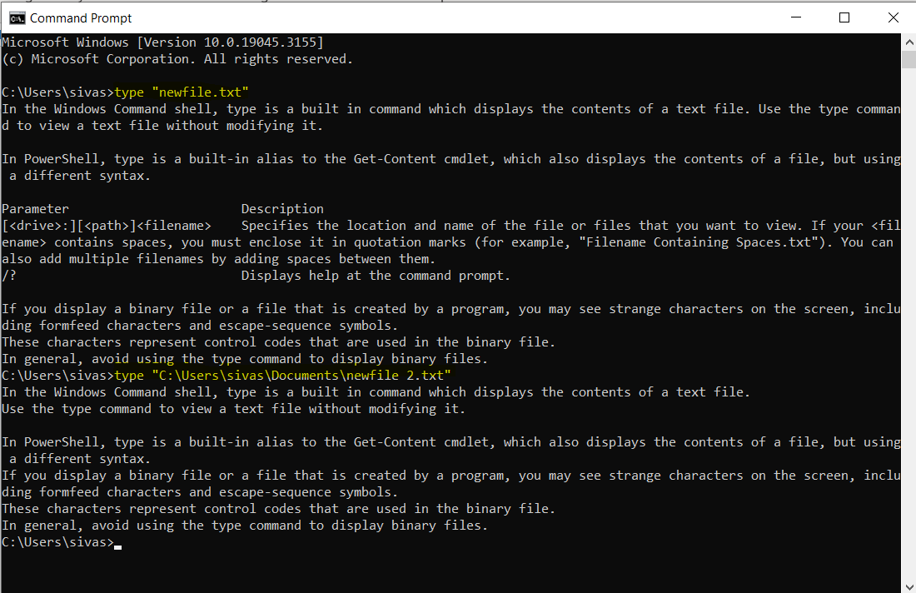

Using PowerShell:
Syntax: Get -content -Path “[<drive>:] [<path>] <file name.extension>“
Function: To view a text file without modifying it and show the file content in PowerShell Window. It show’s the all line of the file it doesn't limit lines while display. Use MORE command with pipe symbol now press spacebar to shows all the line in the large file.
More details: Refer Microsoft Learn
Example:
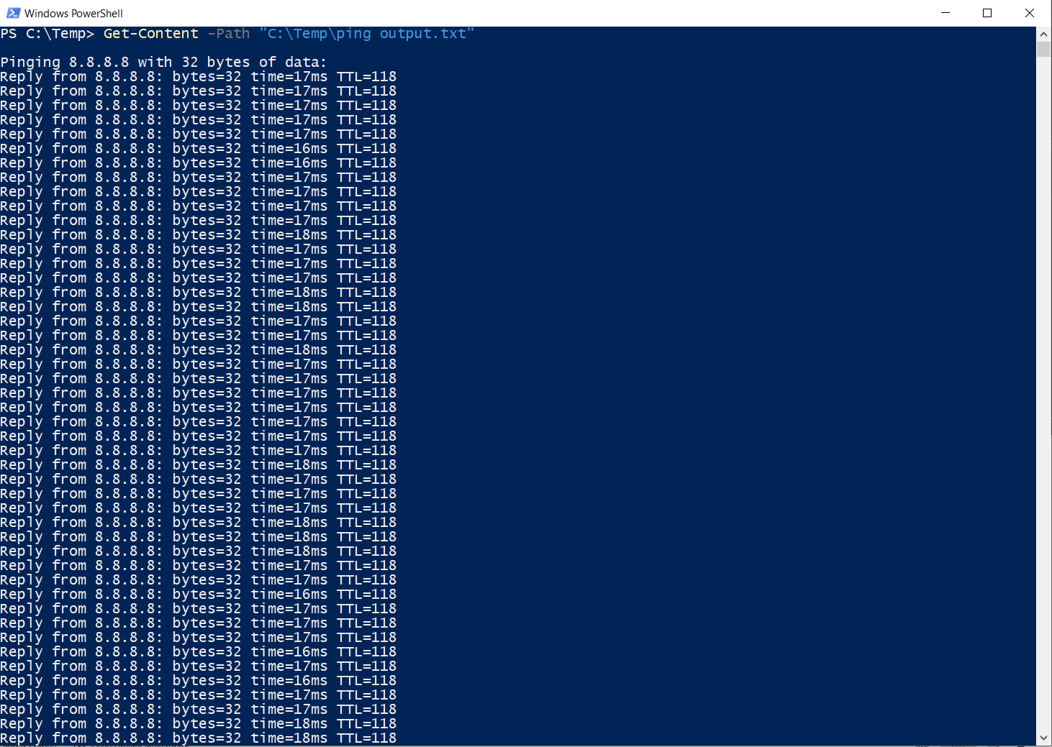

Create and Delete files and directories form windows command prompt

Create empty file:
Syntax: type nul > “[<drive>:] [<path>] <filename>”
Function: it create the empty file in using command prompt.
More details: Refer wikihow
Example:
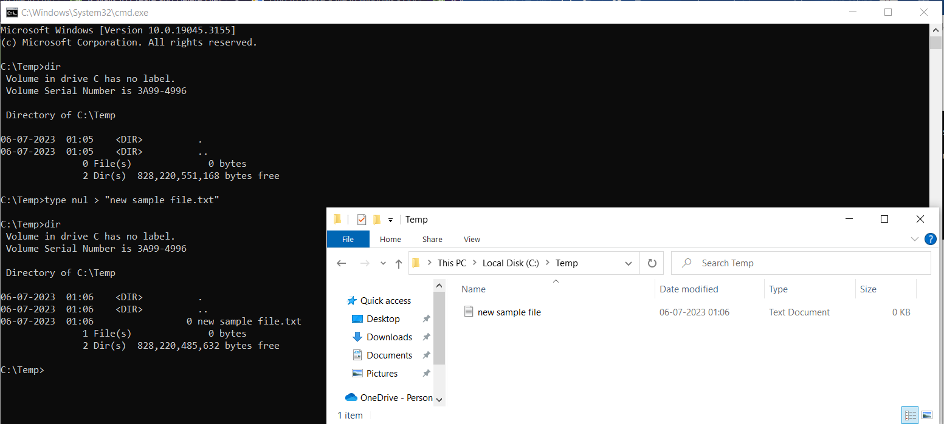

Create a blank file in certain size:
Syntax: fsutil file createnew “[<drive>:] [<path>] <filename>” <length>
Function: To create a blank text file based on byte size.
More details: Refer Wikihow
Example:
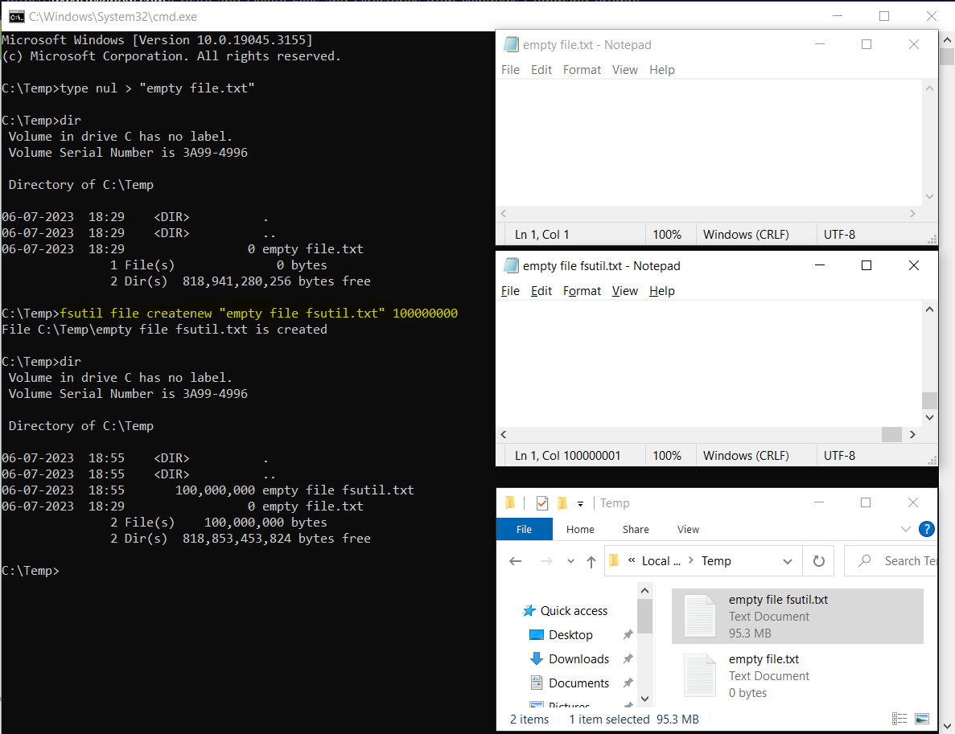

Open files using command prompt
Syntax: “[<drive>:] [<path>] <filename>”
Function: type the file path in command to open any type of file using command prompt with default application which is installed in computer.
More details: Google Search
Example:
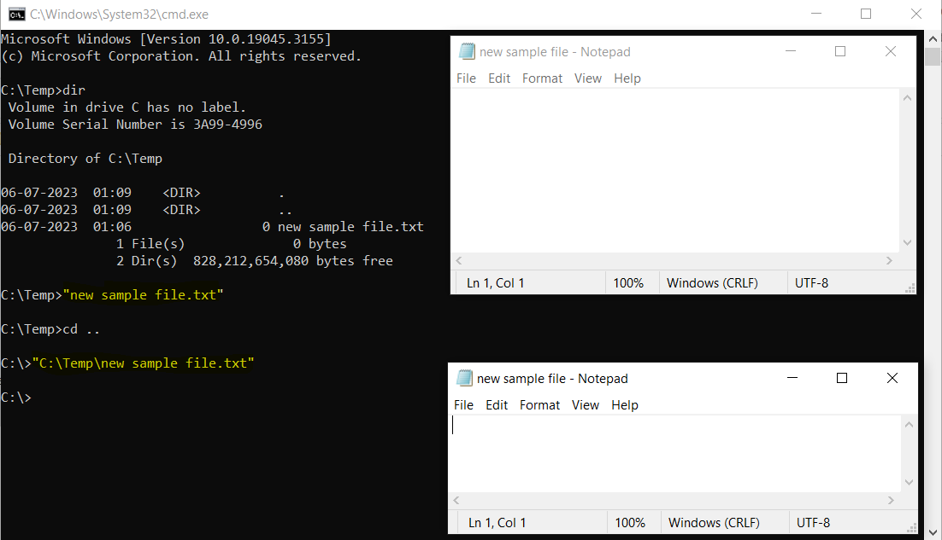

Command output save to a file using Command Prompt and PowerShell

Using Command Prompt:
Create new output file:
Syntax: <your-command> > “[<drive>:] [<path>] <filename>”
Function: command to save the command output to a text file. > is the symbol for create a new text file or over write in existing file to save the output.
More details: Refer Windows Central
Example:
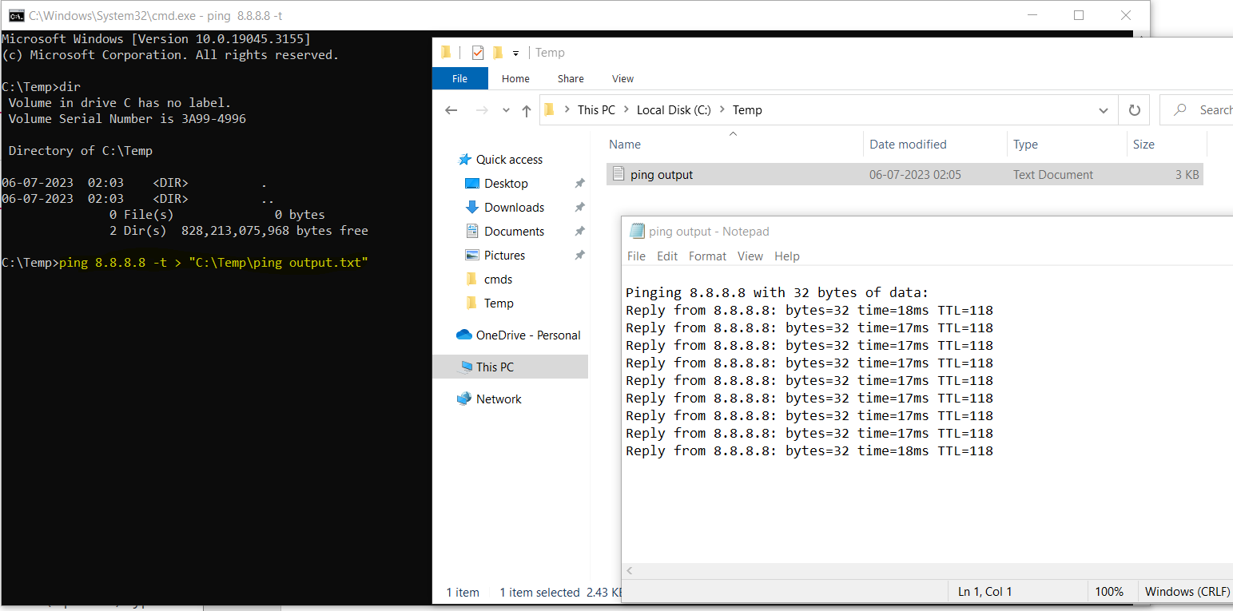
Continue output in existing file:
Syntax: <your-command> >> “[<drive>:] [<path>] <filename>”
Function: : command to save the command output to a text file. >> is the symbol for write existing file to save the output.
More details: Refer Windows Central
Example:
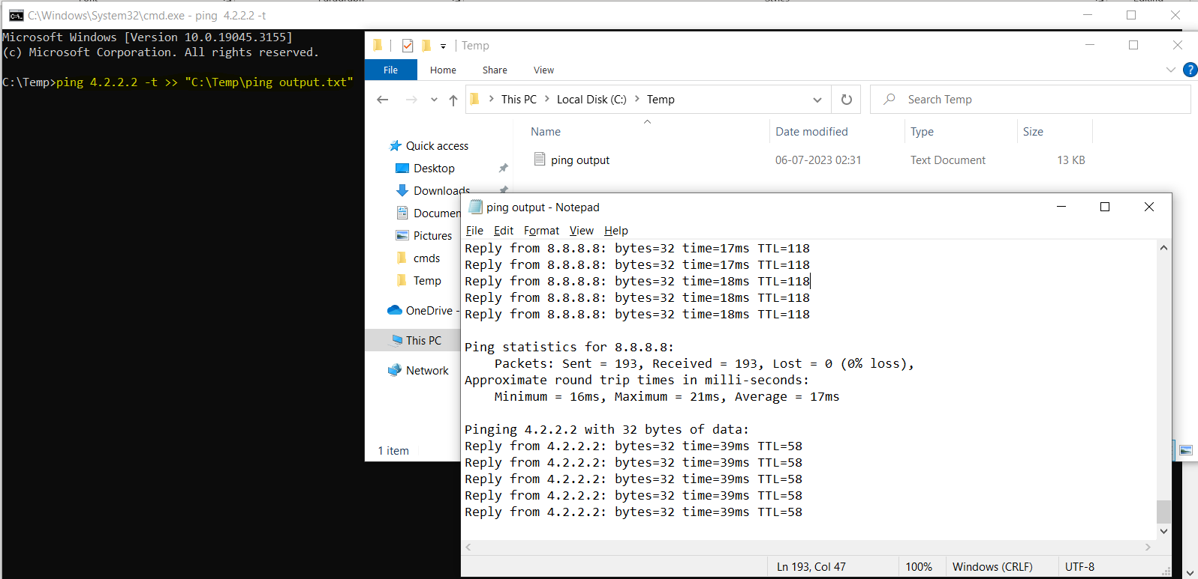

Using PowerShell:
Syntax: ipconfig | Out-File -FilePath “[<drive>:] [<path>] <filename>”
Function: To save the command output to a text file with PowerShell. It will over write the existing file.
More details: Refer Windows Central
Example:
